Alternative to chemistry: how to wash clean a shower stall from the limescale and soap stains.
Contents list:
- Types of cleaning
- Preparation
- Washing a shower stall
- Alternative to chemistry
- Resumes
A Shower stall is a danger for housewives. There is a question that often arises during the cleaning: how and by what means to wash clean different sides of a shower stall without damaging it while washing.

Types of cleaning
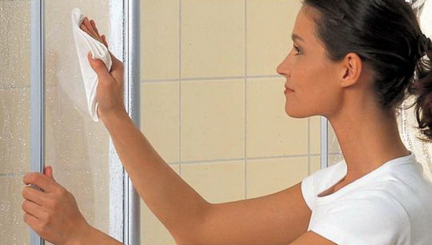
During the process of the shower stall maintenance the following stages can be distinguished:
- Routine maintenance that should be provided after each showering. It should be done properly as follows: rinse all the surfaces with the hot water first and then with the cold one and wipe dry.
- Basic maintenance that takes place within the period from one week to month. In this case, cleaning products with necessary rinsing and wiping dry should be used.
- Intensive maintenance is a cleaning with potent drugs using. It takes place if a shower stall has not been used for a long time, and also in a case of a strong dirt.
- Preparation
To not damage the surfaces and wash clean the dirt effectively it’s necessary to know what materials your shower stall is made from and what products can be used.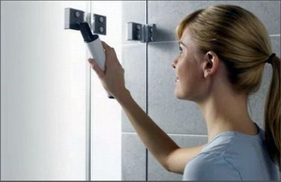
Basically, in the producing of shower stalls following materials are used:
- For walls, ceiling, doors the glass and plastic are used;
- ceramics, natural or artificial stone, acrylic, enamel surface is used for pallets and sometimes for walls of a shower stall;
- chrome plated steel is used for shower heads, faucets, door handles and hinges;
- for frames and guides manufacturing painted aluminum is used.
It’s important to note, while cleaning a shower stall, it’s necessary to refuse of using powder products, hard brushes, and metal sponges.
What can be used? These products are suitable for cleaning:
- polyurethane or rubber scraper;
- cloth made of non-woven fibers;
- synthetic sponge;
- special steam cleaner.

Washing a shower stall
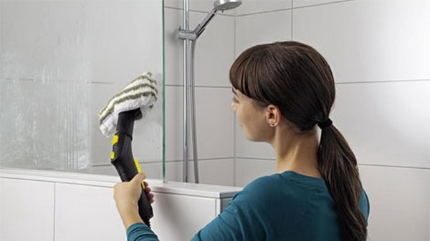
Special sprays are used for washing a shower stall. Usually it doesn’t require an additional rubbing on the surface. But there are situations when you should better apply the product on a cloth and wipe the surface by hands. Thus, to wash door from the inside you should stay in the middle of a shower stall. In this way, if ventilation is poor it can lead to poisoning.
It’s better to remove cleaning product from the door by using a scrapper. It will remove even inconspicuous to your eyes dirt.
Cleaning product usually is washed off by water. It will be enough if a shower stall is not that dirty.
How to wash clean a shower stall from the limescale and soap stains? For these purposes a strong creamy or pasty product is used. It’s applied onto the problem area, and then you should wait for the time specified on the packaging and wash away with running water.
But before you use any cleaning product, make sure it doesn’t contain any component that can harm the covering:
- formic acid;
- formaldehydes;
- organic substances (solvents, acetone)

Alternative to chemistry
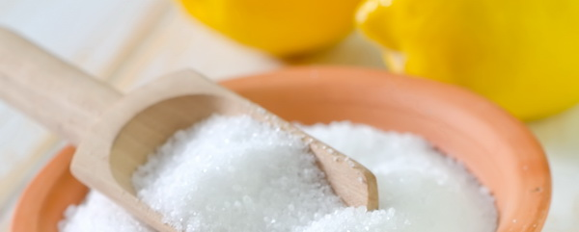
There are time-tested means that can deal with strong dirt. Let’s find out how to wash clean a shower stall with folk remedies.
To clean out glasses, faucets and mirrors you need to take one tablespoon of vodka and two tablespoons of water. Wet the towels in this solution, wipe dirty surfaces with it and then wipe dry all the surface.
To clean out metal elements or acrylic pallet from the dirt you can use a simple toothpaste. You only should apply it on the needed area with the thin layer and wash away with the water.
But to get rid of a rust you can enlist the help of a vinegar. Spray it with an atomizer onto the surface, leave for a half an hour and wash thoroughly.
Some methods are known of how to wash clean a shower stall with a citric acid:
- Mix 20 g of soda, 30 g of citric acid in a glass of warm water. Pour all of it in the atomizer, blend thoroughly and spray onto the tile or walls of shower stall. Wait for 10 minutes and wash away with water. Processed surfaces will shine.
- You can clean the surfaces with citric acid by dissolving it in a little amount of water. Apply onto the problem area with a cloth, wait a little bit and wash with the water. 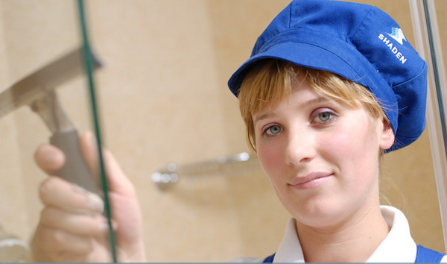

Resumes
What words of advice can be written in the end:
Doors of the shower stalls can be cleaned with window cleaner and then wipe with two-sided scraper (rubber is from the one side, sponge is from another side). This method is used by maids in hotel during the everyday cleaning.
- Be careful when using soda while cleaning plastic. Soda can scratch this material quite often.
- Wash out the toothpaste from the surfaces right away. You had better do this than rub away dried toothpaste after.
- It’s necessary to wipe dry the surfaces after cleaning. Thus, the limescale won’t be formed.
- Leave the shower door slightly open. So, you can prevent the formation of fungus. For the same purposes ventilate the bathroom periodically.

